**Spring Tool Suite (STS) – Create a dynamic web project using maven**

Tools used

* Spring Tool Suite (version: 3.9.4.RELEASE)
* Maven (version: 3.5.2)
* Java (version: 1.8)
* Tomcat (version: 9.0.2)

Steps

1. Create new Maven project
2. Configure Tomcat
3. Create src/main/java and src/test/java folders, if there aren’t any
4. Run the application

Screen shots

**Step 1 –** Create Maven web application project using either Eclipse IDE or STS

1. Click New->Maven Project
   1. Select default location
   2. Select “maven-archtype-webapp”.
   3. Enter Group Id, Artifact Id, package details and hit finish

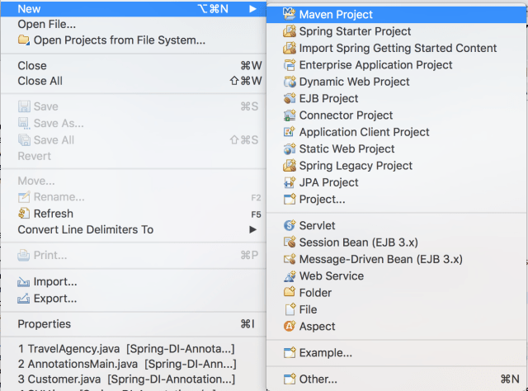

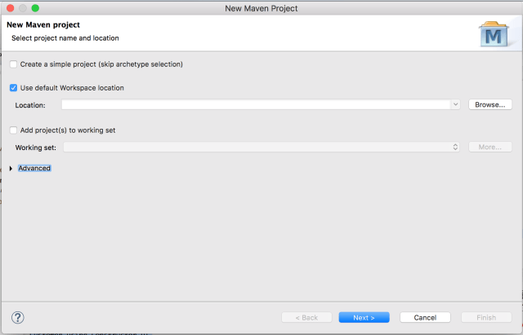

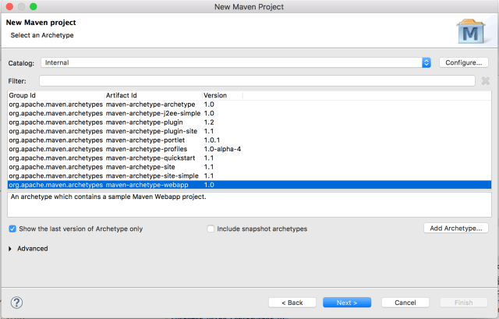

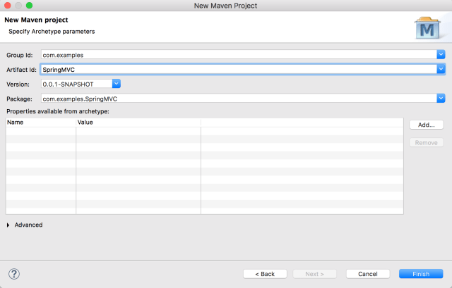

Below is the project structure after hitting finish

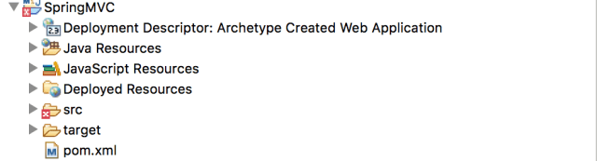

**Note:**If you look in the problems view, the error is “The superclass “javax.servlet.http.HttpServlet” was not found on the Java Build Path. This error indicates that http-servlet is not available in the project class path, once we add target-runtime to the project , http-servlet will be available in the project class-path.

Errors will be resolved after configuring run time server such as Tomcat server

**Step 2 –** To configure Tomcat server:

1. Right click on project and select “Properties”.
2. Select “Targeted Runtimes” on left hand side.
3. Select “Apache Tomcat v9.0”.
4. Click apply and close

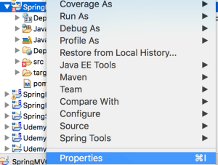

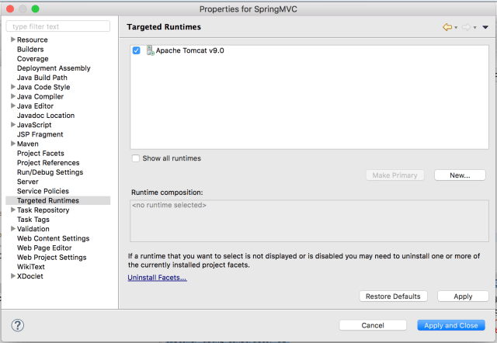

**Step 3 –** To create src/main/java and src/main/test folders,

1. Right click on project structure, select “Properties”,
2. Select “Java Build Path” on left hand side
3. On right hand side, select “Order and Export” tab
   1. select “Maven Dependencies” and “JRE System Library”
   2. select apply and close

**Note: If you still see errors, right click on project and do Maven -> update project**

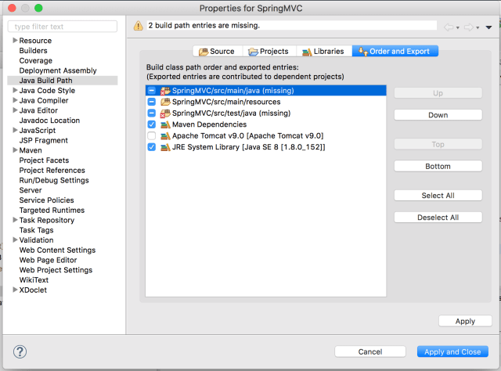

**Step 4 –** Run the application

1. Right click on project, select Run As and Run on Server
2. Select Tomcat server in the window
3. Select Finish
4. Type http://localhost:8080/SpringMVC/ in your favorite web browser to see “Hello World” message

